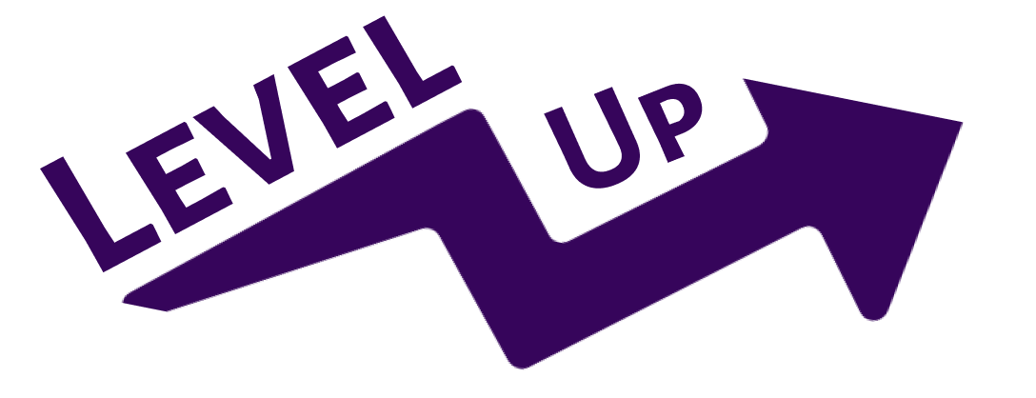

**Build Human Skills One Experience at a Time**

Varsha Saravanan | Nick Pyun | Maroua Bezzoui | Taralyn Nguyen

**Prototype:** <https://www.figma.com/design/es91eTUsey43WM8EawUq4V/MedFi?node-id=0-1&t=MD9Zpi29n5qhxf2I-1>

**Target Audience:** Level Up is for students and early career professionals who want to boost their human skills (interpersonal or soft skills) to enhance their personal and career development.

**Design Tools:**

Our Medium Fidelity Prototype was designed and prototyped on Figma, allowing for ease in iterating, collaborating, and testing. Our prototype is designed to serve as a mobile-based application with respective dimensions, compatible with IOS and Android Devices.

**Operating Instructions:**

**General Info:**

* To run the flow prototype, start from the first onboarding screen. This is labelled as “Start Here: Log In/Sign Up”

**Onboarding:**

* When users open Level Up, they will be on the first onboarding page that presents two ways of accessing the app: Log In (for existing users) and Sign Up (for new users).
* Log In
  + Upon successfully entering users’ email and password, they see a popup box stating “You’re all set!” and are allowed access to the app.
  + If the user has forgotten their password, they can click the “Forgot Password?” part of the screen and will be prompted to enter their email address to have a recovery link sent to their inbox.
  + Users can navigate back to previous screens using the back button on the upper left and can navigate forward to subsequent screens using the next button in the lower left.

**Navigation Bar:**

The navigation bar will appear on the bottom of all screens except for the onboarding flow, allowing users to navigate to almost any part of the app from any screen.

* **Home** (first from left to right)
  + The Home icon brings users to the home screen, which serves as the central screen of the app and will be the first that users see when they log in. Users can find their Daily Challenge and browse through the different skill categories offered by Level Up.
* **Experience** (second from left to right)
  + The Experience icon (represented by a star) brings users to “My Experiences” where they can toggle to their saved and completed tasks.
* **Leaderboard** (third from left to right)
  + The Leaderboard icon leads to a Leaderboard List where users can view their friends’ XP points, and rankings, and challenge them to complete a task. Users can view a list of all members who users can add as friends or challenge to complete a task
* **User Profile** (fourth from left to right)
  + The profile icon takes the user leads to the user profile page where they can find information about their progress (in XP points) in different skills with a graph depicting progress over time.

**Home Screen**

* When users are on the Home screen they are greeted using their first name and can view their Total Experience points (XP), which is embedded within the purple star icon.
* Users are also able to view their current streak which is represented by purple stars in the weekly calendar.
* **Tasks:**
  + Users can view their Daily Challenge under “Today’s Task” or scroll further to view the four different skill categories (Communication, Problem-Solving, Leadership, Adaptability) and explore more tasks to complete
  + **Task Card:** 
    - Each Task is represented by a task card, which on the front side, the users can use to save the suggested task for later (by pressing the bookmark icon,) or indicate that they are uninterested in the task (by pressing the “X” icon at the bottom of the card).
    - Users can navigate to the back side of the card using the arrow button in the top right for a detailed description of the assigned task and the reflection box for users to fill out upon the completion of the task.
  + **List of Skill Categories:**
    - This section is found under the Daily Challenge, serving as a way for users to explore more tasks across the four different categories.
    - Additionally, there is a “Coming Soon” section to indicate that there are more skills that are to come

**Profile**

* When a user clicks on the profile icon, they are taken to their profile page. Here, they are able to view their profile picture, followed by their total XP points. Users are also able to view a skill wise breakdown and visual representation of how much XP they’ve gained in each category.
* Further, if users click the “View Trends” button they can toggle to see a skillwise progress graph for the past 30-days and for all time.

**My Experiences**

* When the user is on the “My Experiences” page, they are able to toggle between saved and done tasks. Here, users are able to view their completed tasks as well as the tasks that are saved for later.

**Leaderboard**

* This screen contains a Leaderboard list where users can view their friends’ XP points, and rankings, and challenge them to complete a task. Users can view a list of all members who users can add as friends or challenge to complete a task that the user has already completed. They can toggle between a leaderboard of only their friends, or that of all app users to whom they can send a friendship request.

**Limitations**

* There is no functionality for the search bar at the leaderboard, but that is mostly due to the limitations of Figma, but that should be implemented using ReactNative backend coding.
* Users are unable to type-in their information while onboarding because the prototype on Figma tools cannot ingest typed user input..
* Users are not able to edit their profile/access profile & security settings in the Figma prototype because it cannot ingest typed user input and perform the necessary logical calls to change the displayed information.
* Only the task in the home screen (Rubik’s Cube) has all buttons clickable and functioning (Bookmark, delete, arrow, Navigation bar, etc) , other buttons require a longer time to animate all on Figma.

**Wizard of Oz techniques & hard-coded items:**

* **Static leaderboard:** The list of friends and their levels in the leaderboard are hard-coded as we don’t yet have active user friends progressing in their learning.
* **Friend Request Functionality:** Pressing the “Add a Friend” button would not send the friend request

**Why?** We do not have a backend system to dynamically store these operations.

* **Progress Graphs and XP Levels:** The progress graph that displays users' advancement in various skills is currently fictional. Users will not see real data reflecting their actual learning achievements, which may affect their perception of progress and satisfaction with the app. This limitation is a critical factor as tracking progress is vital for user motivation and goal-setting.

**Why?** No real progress has been achieved.

* **Limited Task Availability:** The app only offers a small selection of tasks for each skill category to illustrate the user flow. This constraint means users may find the experience somewhat repetitive or insufficiently varied. As we do not yet have a robust backend system capable of dynamically generating tasks tailored to user preferences, the diversity of tasks is significantly restricted.

**Why?** We do not yet have a backend stack where enough tasks are stored for each skill and which can be generated in a specific order.